- Design the Below Application with fieldset and legend
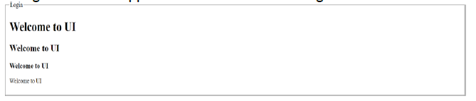

Code
<!DOCTYPE html>
<html lang="en">
<head>
<meta charset="UTF-8">
<meta name="viewport" content="width=device-width, initial-scale=1.0">
<title>Document</title>
</head>
<body>
<fieldset>
<legend>login</legend>
<h1> Welcome to UI</h1>
<h2> Welcome to UI</h2>
<h3> Welcome to UI</h3>
<h4> Welcome to UI</h4>
<h5> Welcome to UI</h5>
</fieldset>
</body>
</html>
Output :

